The following pictures in figs. 1-8 shows the evidence captured during Investigation (see pictures below).
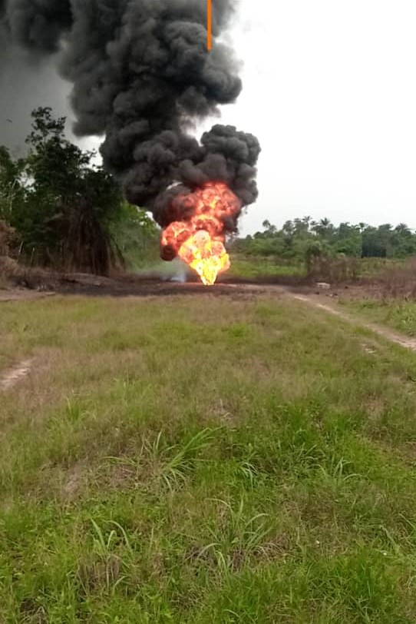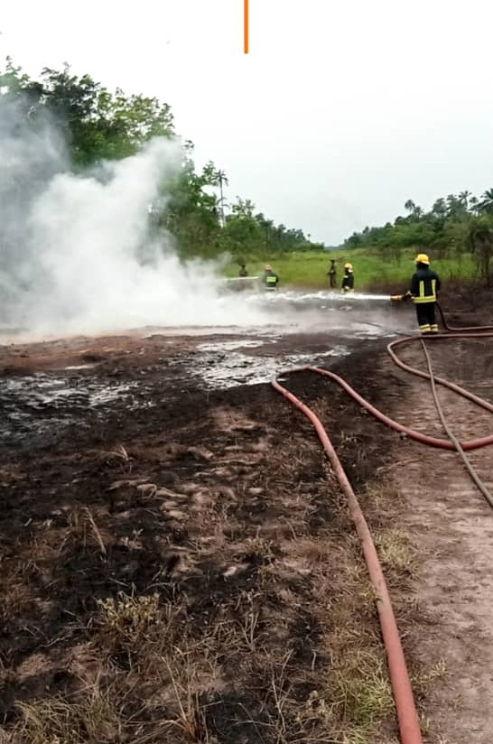
Figure 1. The fire Incident Figure 2. Firemen extinguishing the fire

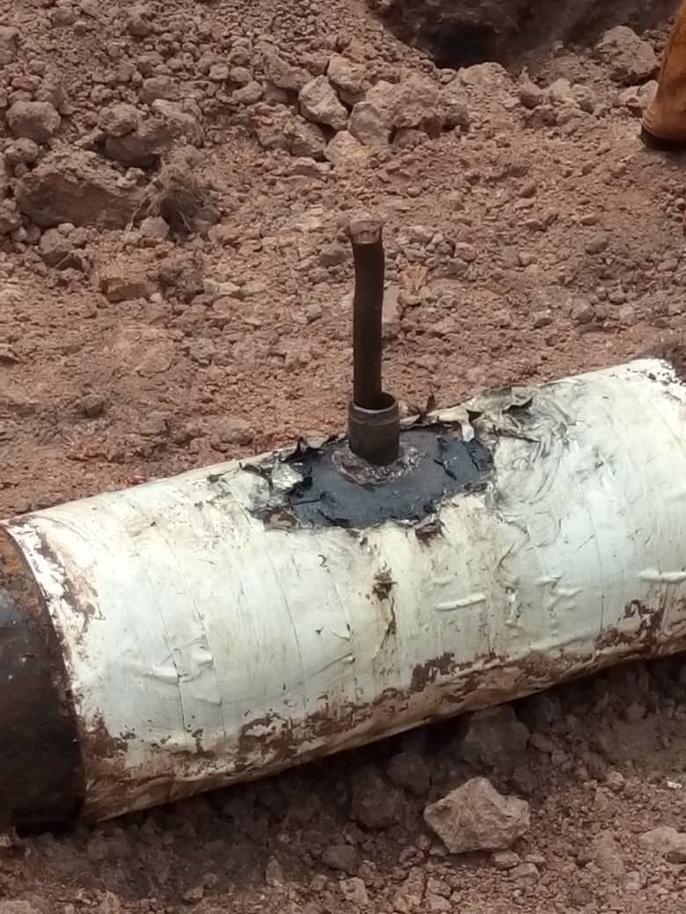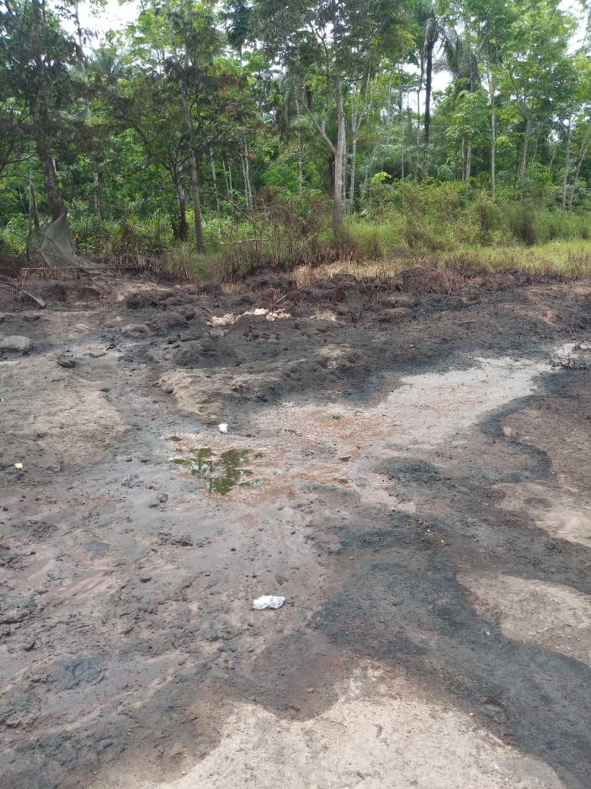
Figure 3. Spill point with Nipple Installation Figure 4. Burnt vegetation stained with oil
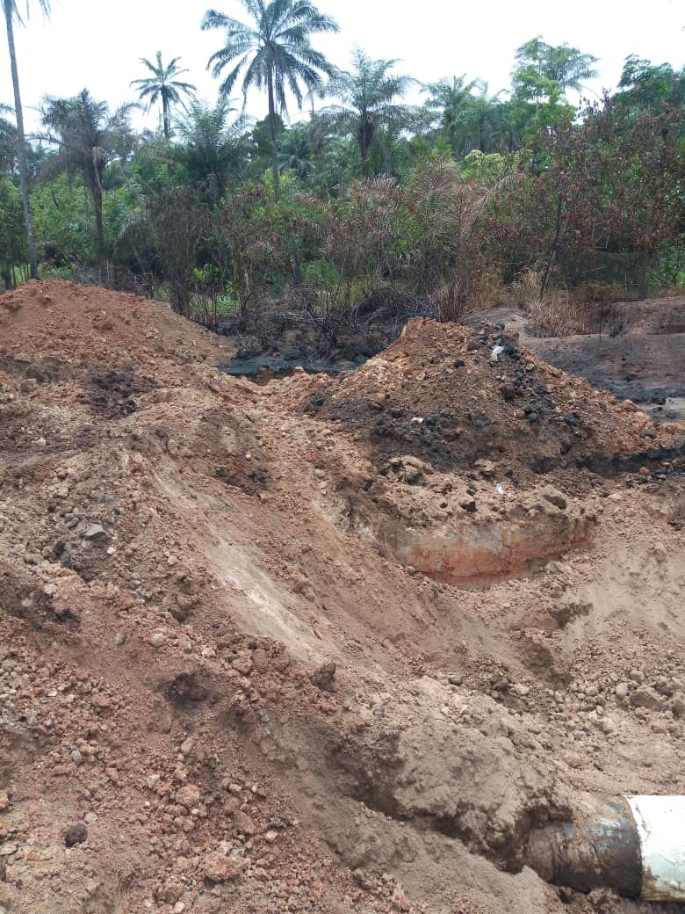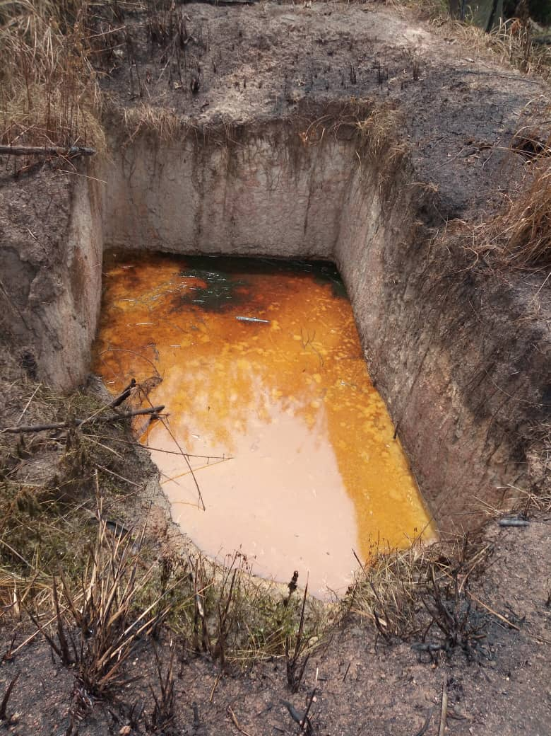
Figure 5. Carbonized soil from fire Figure 6. Oil impacted fishing Pond
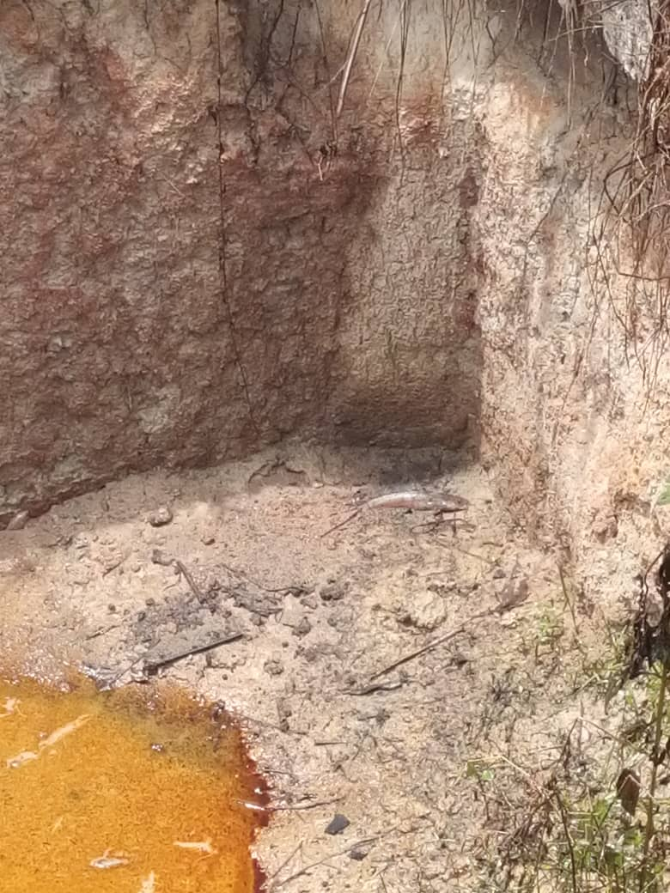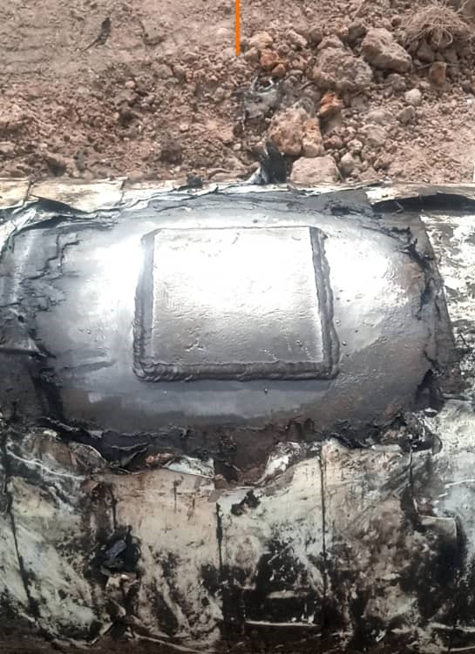
Figure 7. One of the dead fishes in the pond Figure 8a. Repairs is ongoing
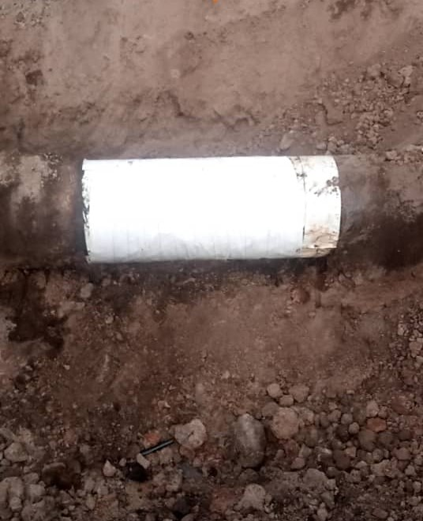
Figure 8b. Repairs completed

